|  |
| --- |
|  |
| ***Project Report On***  (Nail Art)  Name: Nimrah Rani (student 1520931)  Partner Name: Simrah Emanuel (student 1520920)  Batch: 2309d TTS  Center Name: Aptech site Center |
| |  |  |  | | --- | --- | --- | | Sir M. Moosa |  | e-project | |

**Project Report On**

**Nailuxe**

**Table Of Contents**

1. **Acknowledgments**
2. **Information About Developers**
3. **Introduction About Project**
4. **Analysis**
5. **Screen Shots**
6. **Final Statement**

**Acknowledgments**

The combine Study on this project is an honor for our group members.

We were eager to make such a dynamic and interesting project, which may provide us with a huge amount of practical knowledge and will help us use our skills efficiently.

Our heartiest appreciation and gratitude towards our teachers, whose help, dedication and encouragement has helped our team members to successfully, achieve our goals.

We are grateful to Aptech for providing us necessary facilities and the support which we needed and also for providing us the opportunity to practically implement what we have learned, which will help, help us in future.

**Information About Developers**

|  |  |
| --- | --- |
| **Student1520931** | **Nimrah Rani** |
| **Student1520920** | **Simrah Emanuel** |

**Introduction About Project**

"Project Nail Art" is a celebration of creativity on fingertips, where nails become canvases for self-expression. Through innovative designs and meticulous craftsmanship, it transforms manicures into wearable art. Join us in exploring the boundless possibilities of nail adornment and unleash your unique style.

This project seamlessly combines HTML, CSS, JavaScript, and Bootstrap to create an immersive and user-friendly website that caters to both aesthetic appeal and functionality.

By leveraging modern web technologies, the website provides a visually stunning experience while ensuring seamless navigation and easy access to information.

**Analysis Purpose**

The analysis of **nail art** serves to delve into its multifaceted significance within contemporary culture. It seeks to understand the sociocultural, psychological, and aesthetic dimensions of nail art as a form of self-expression. By examining trends, techniques, and the evolution of nail art, the analysis aims to uncover its role in shaping individual identity, fostering creativity, and reflecting societal values. Additionally, it explores the economic impact of the **nail art** industry and its influence on beauty standards and fashion trends. Through this analysis, a comprehensive understanding of the cultural phenomenon of nail art emerges, providing insights into its enduring popularity and relevance in today's world.

***Snapshot***

**Home page**

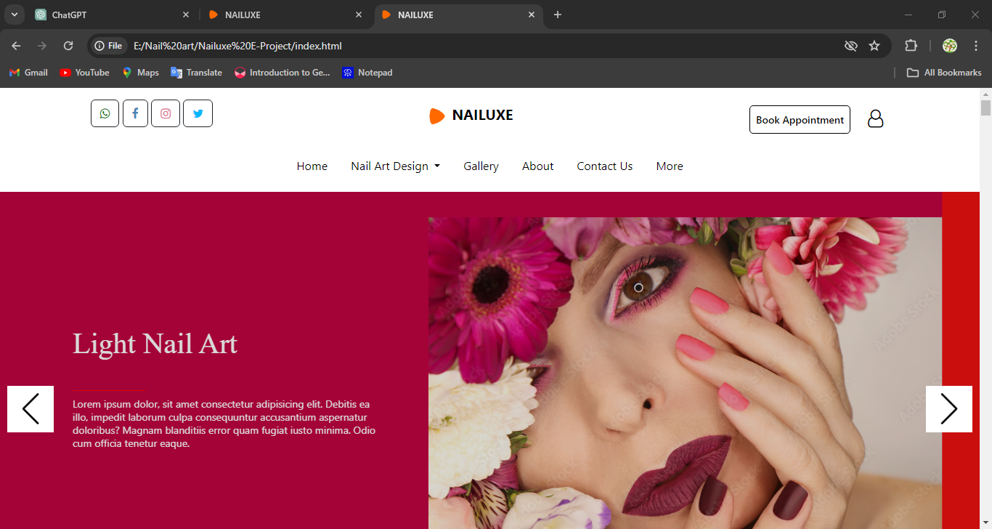

**About Us**

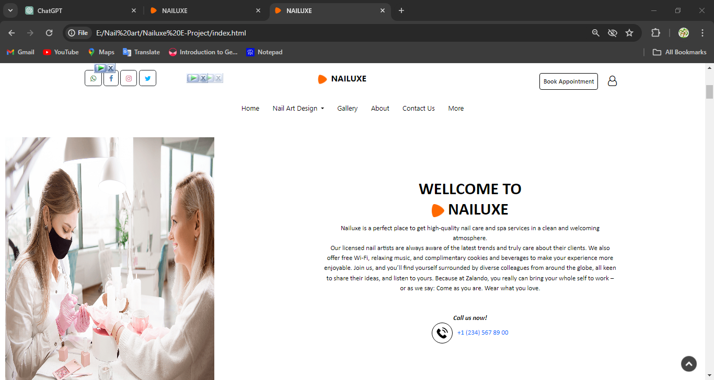

**Our Services**

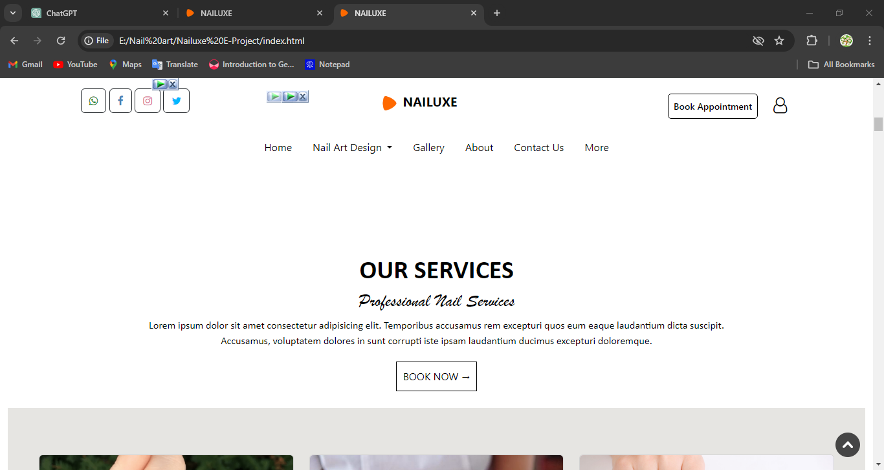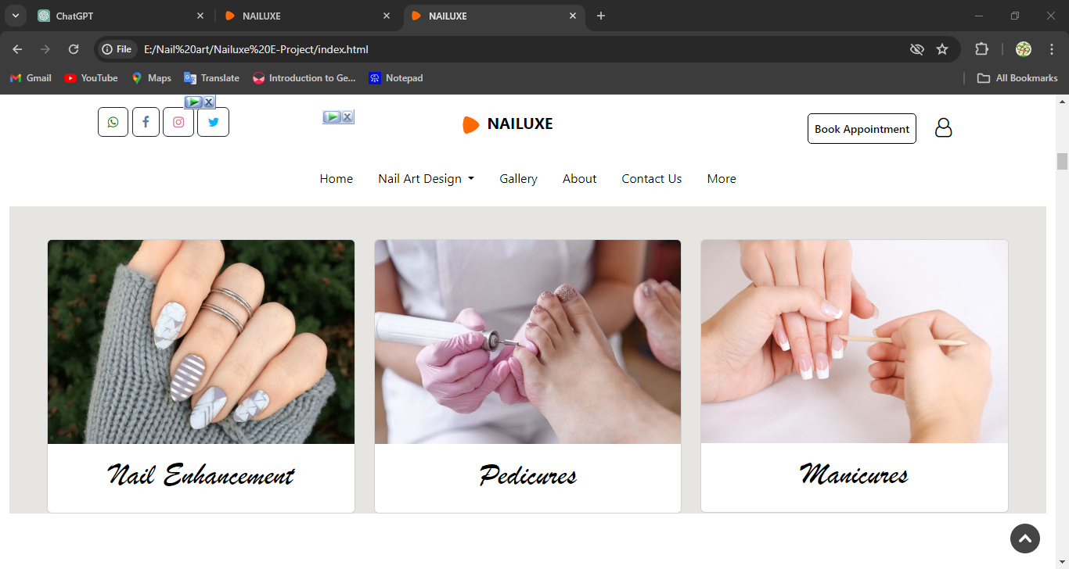

**Category**

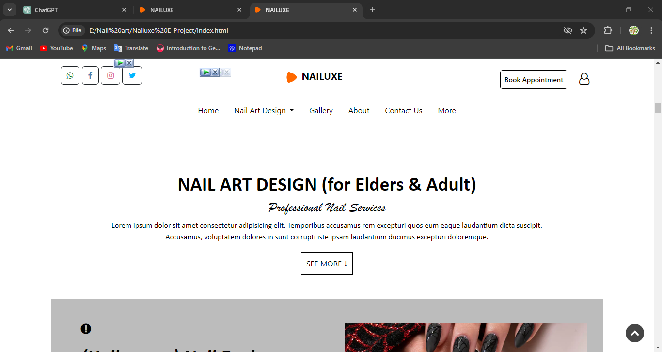

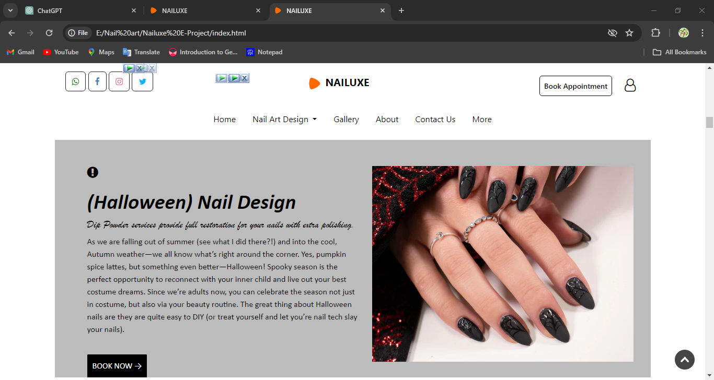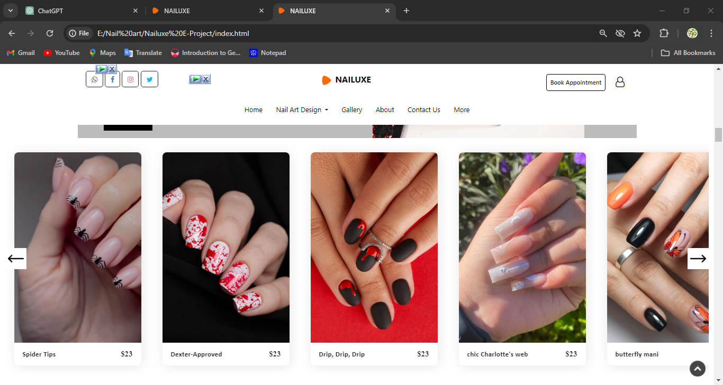

**Our site location**

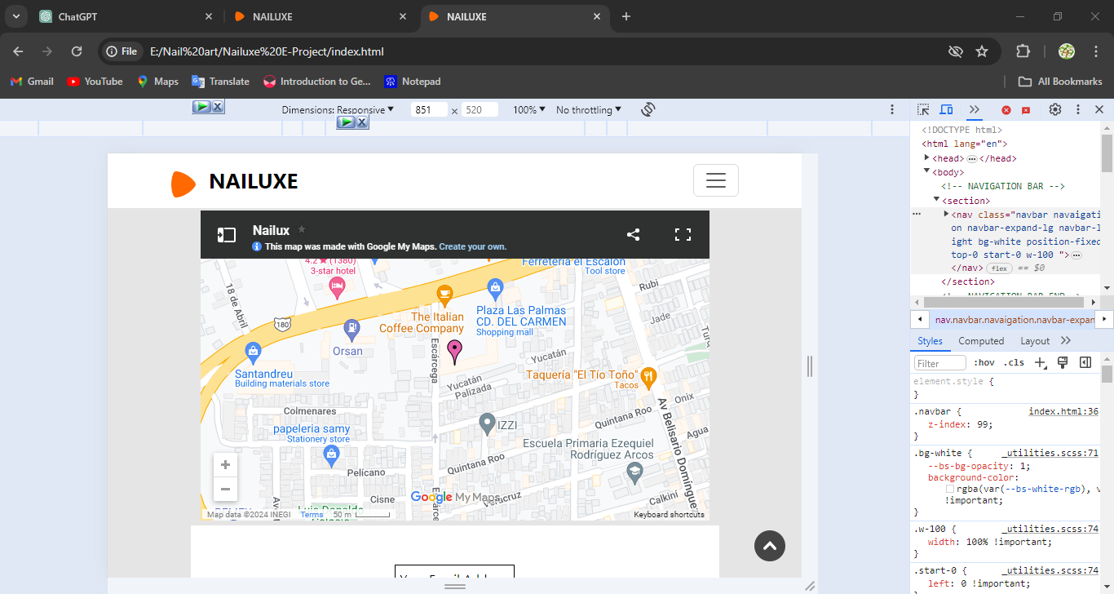

**Contact us page**

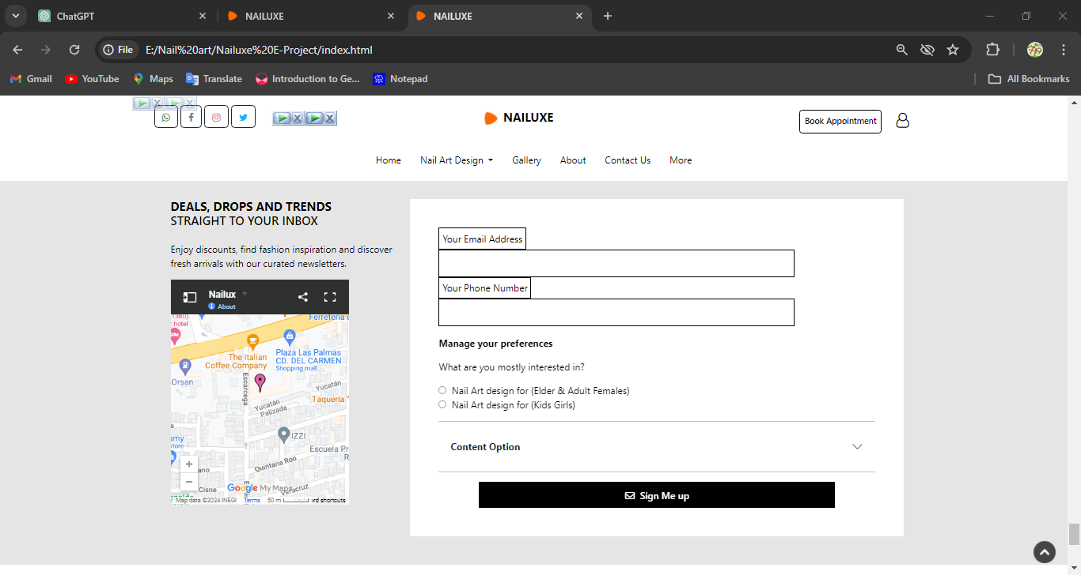

**Gallery**

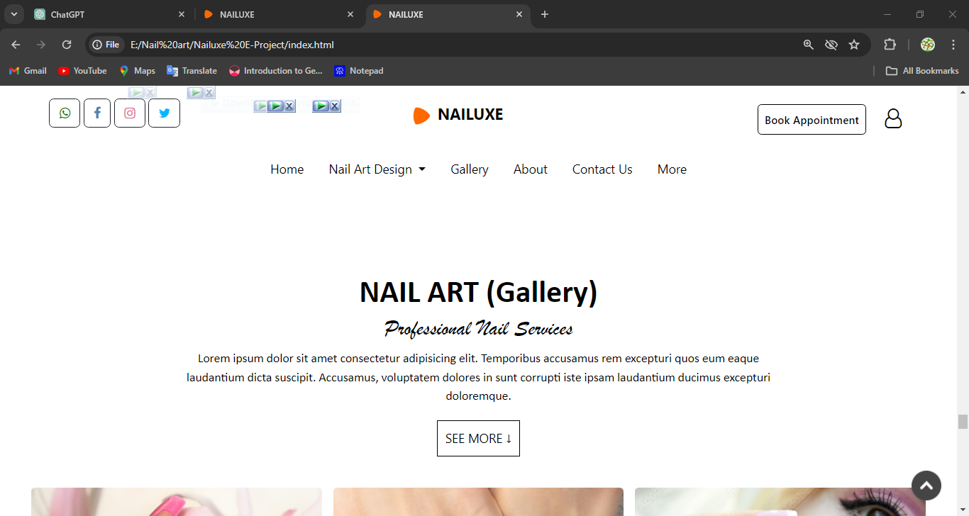

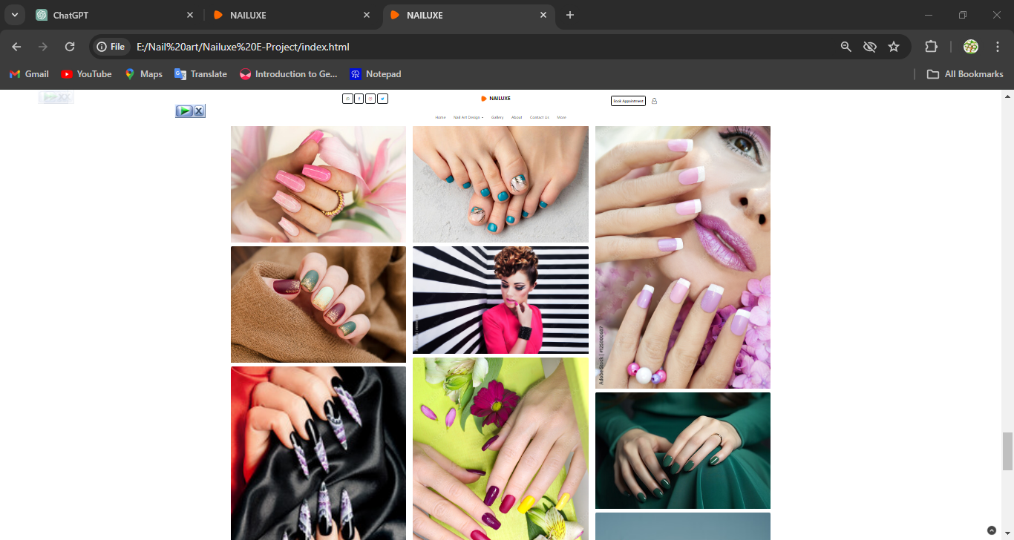

**Nail art Website Info**

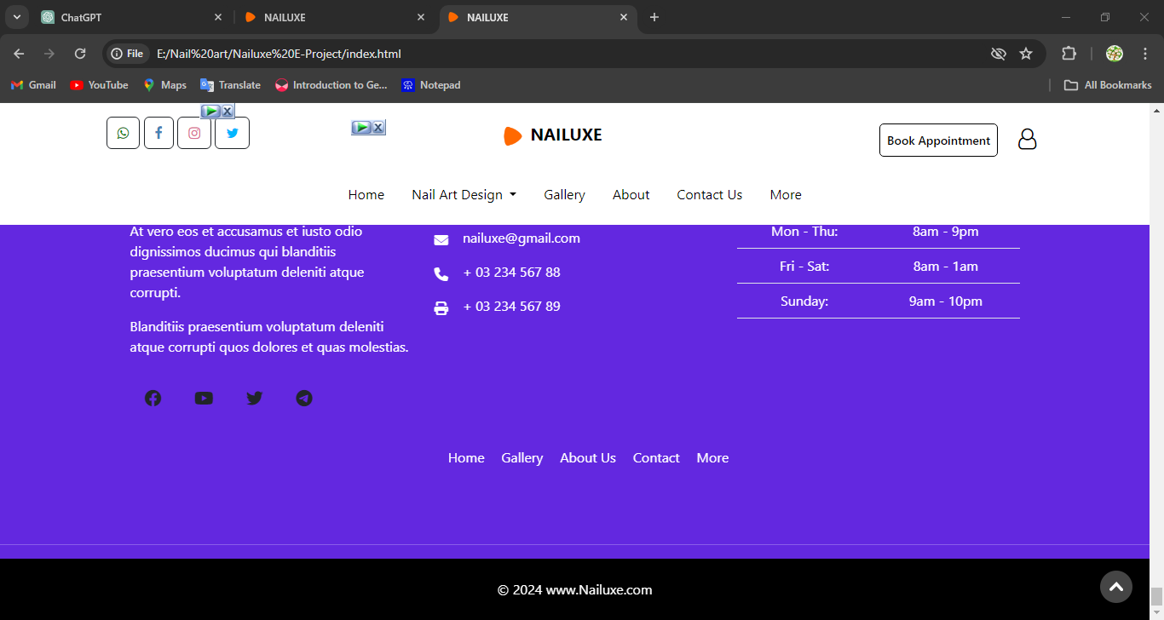 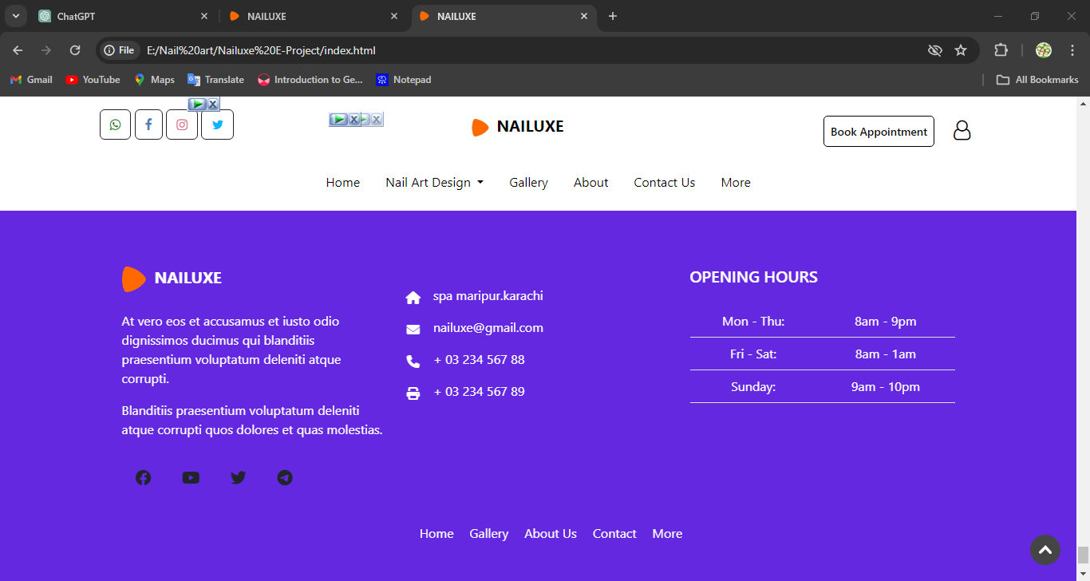

**Final Statement**

This E Project was created with Firm Determination. We students did lot of hard work to complete this project on time.

We did our best to made this project perfect, work full, help full, easy to use and Qualified as much as possible.

We Kept the future technologies and usage in our mind while making this project.

We hope That APTECH will like our project and will appreciate our hard work and Firm Determination.

THANK YOU!